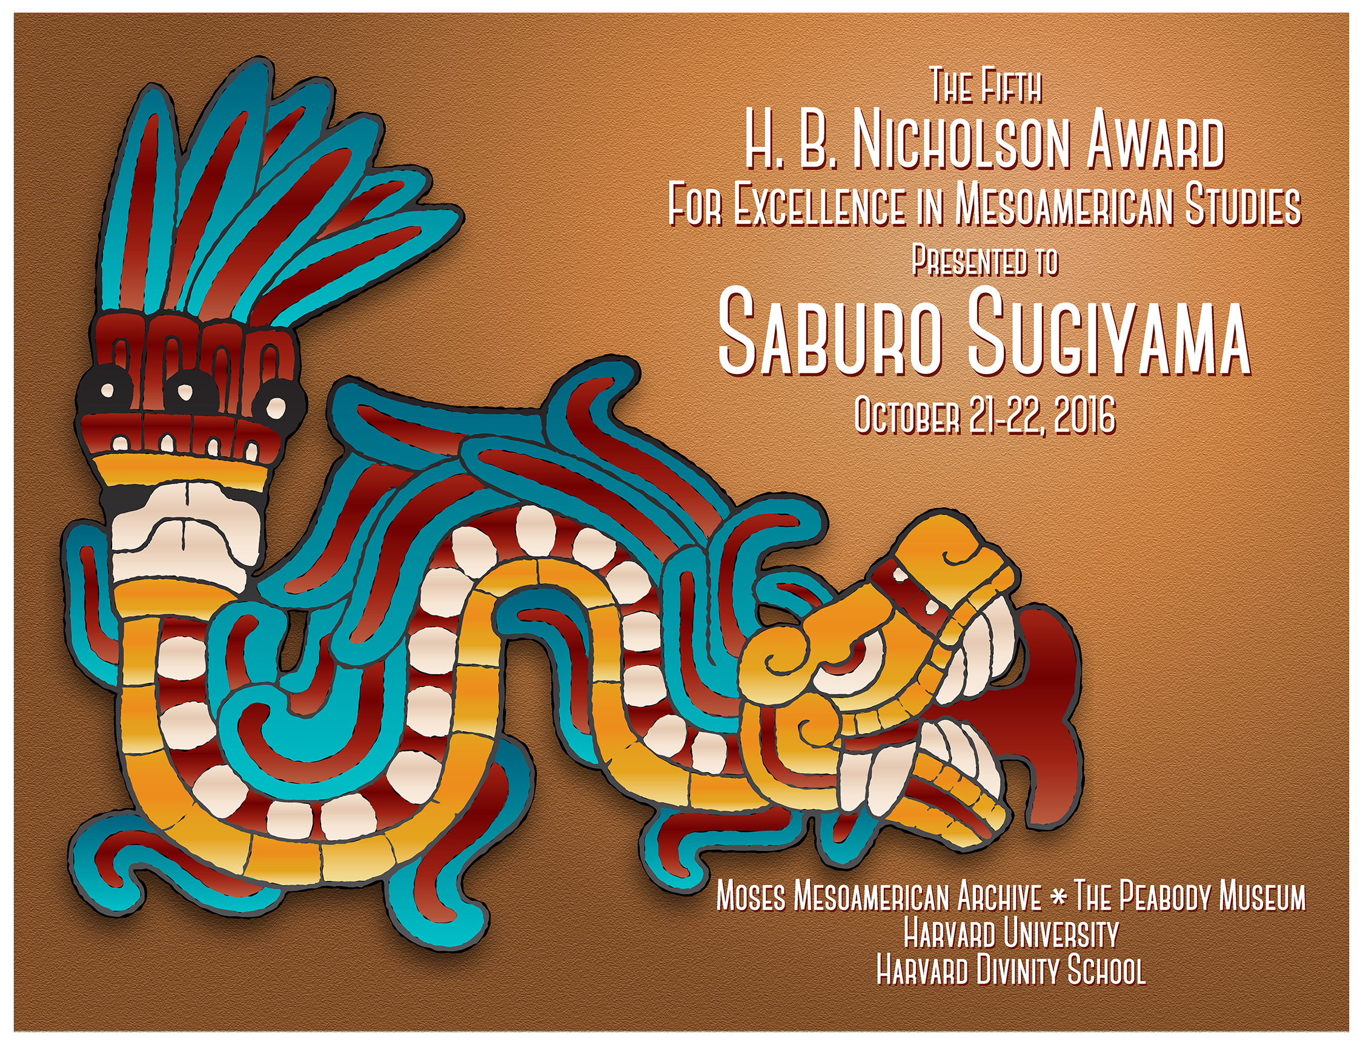

As Above, So Below:
Cosmic Roads to Mesoamerican Underworlds
A symposium in honor of Saburo Sugiyama
October 21 – 22, 2016 ~ Harvard University

FRIDAY OCTOBER 21
9:00 – 9:30 Welcome and Opening Remarks – Rabinowitz Room, Andover Harvard Theological Library
Davíd Carrasco, Moses Mesoamerican Archive, and Eduardo Matos Moctezuma, Templo Mayor Founding Director
David Hempton, Harvard Divinity School Dean of the Faculty

9:30 – 10:00 “Up and Down at Teotihuacan, Tenochtitlan, Copan, and Elsewhere”
Anthony Aveni, Colgate University

10:00 – 10:30 ”La verticalidad del cosmos”
Alfredo López Austin, Universidad Nacional Autónoma de México

10:30 – 10:45 Break

10:45 – 11:15 “Layering Above and Below: What the Codex Ríos Says about the Aztec Cosmos at the Dawn of Creation”
Elizabeth Hill Boone, Tulane University

11:15 – 12:00 Discussion
Moderator: Davíd Carrasco, Moses Mesoamerican Archive

12:00 – 12:45 Lunch Break – Braun Room, First floor of Andover Hall

12:45 – 1:15 Short Retrospective Film from the Moses Mesoamerican Archive

1:15 – 1:45 “Buried Cosmos: Creation and Royal Accession Rituals from the Copan Underworld”
William Fash, Harvard University, and Barbara Fash, Harvard University

1:45 – 2:15 “A Space for Transformation: Darkness and Underworld in the Temple of the Inscriptions at Palenque”
Laura Filloy Nadal, Museo Nacional de Antropología, INAH-Mexico

2:15 – 2:45 Discussion
Moderator: Charles Golden, Brandeis University

2:45 – 3:00 Break
3:00 – 3:30 “From the Pillar of Death to the Cross of Miracles: Shifting Roadways to the Underworld in Mitla, Oaxaca”
Lindsay Jones, The Ohio State University

3:30 – 4:00 “Shape-shifters, alter egos, and ancestral spirits: The imagery of the ‘Fire Serpent’ in Mesoamerica”
Javier Urcid, Brandeis University

4:00 – 4:30 Discussion
Moderator: William Fash, Harvard University

SATURDAY OCTOBER 22

9:00 – 9:15 Gather in Rabinowitz Room, Andover Harvard Theological Library

9:15 – 9:45 "El encuentro con los ancestros fundadores de Teotihuacán: Manifestaciones de lo sagrado bajo el
Templo de La Serpiente Emplumada y en el escenario ritual de La Ciudadela"
Sergio Gómez Chávez, Instituto Nacional de Antropología e Historia

9:45 – 10:15 “Producing pyramids, linking caves: Offering complexes in the Sun Pyramid and Teotihuacan, Mexico”
Nawa Sugiyama, George Mason University

10:15 – 10:45 Discussion
Moderator: David Carballo, Boston University

10:45 – 11:00 Break

11:00 – 11:30 “Becoming God. The Transformation into Divine Beings in Mesoamerica”
Markus Eberl, Vanderbilt University

11:30 – 12:00 “Clouds of the Moon, Fires of the Sun: Some Reflections of the Feminine Divine as a
Source of Rain and Sweet Water”
David Freidel, Washington University in St. Louis

12:00 – 12:30 Discussion
Moderator: Nicholas Carter, Harvard University

12:30 – 1:15 Lunch Break

1:15 – 1:45 “Entering the Underworld: Archaeological excavations at the foot of the Great Temple of Tenochtitlan”
Leonardo López Luján, Templo Mayor Project, Director

1:45 – 2:15 “The journey to the Underworld: archaeological analysis of funerary goods from the Templo Mayor of Tenochtitlan”
Ximena Chávez Balderas, Templo Mayor Project/Tulane University

2:15 – 2:45 Discussion
Moderator: Elizabeth Hill Boone, Tulane University

2:45 – 3:00 Break

3:00 – 3:30 “The Sun’s Underworld Path. Images of El Zapotal in Veracruz”
Sara Ladrón de Guevara, University of Veracruz

3:30 – 4:00 “Bridging the human and the divine at the Great Pyramid of Cholula”
Gabriela Uruñuela, Universidad de las Américas - Puebla, and Patricia Plunket, Universidad de las Américas - Puebla

4:00 – 4:30 Discussion
Moderator: Javier Urcid, Brandeis University

4:30 – 5:00 Final Remarks: Saburo Sugiyama
Discussion: Davíd Carrasco, Eduardo Matos Moctezuma

This conference was organized by the Moses Mesoamerican Archive, Harvard University. We are grateful to Harvard Divinity School for use of the Rabinowitz Room and Braun Room, to the Peabody Museum for use of the Hall of the North American Indian, to Barbara Fash for providing the Hacmack Box image for the conference, and to Cory Kellerson for creating this year’s design of the award symposium announcement.

